Application form to have a Gig or Sports Buddy
Date: __________________________
Your name:

….......................................................................................

Do you have a learning disability and/or autism?

c Yes

c No

Your date of birth:
…...........................................................................................
Layout in table cell | Your address:  …..........................................................................................  ….........................................................................................  …...........................................................................................
Your telephone numbers:

Home: …....................................................................................

Mobile: …....................................................................................

Your email address:

…….........................................................................................
What is the best way for us to contact you?

c Phone

c Email

c Video call

c Speak to my support worker or carer

Please tell us the contact details for your support worker or carer:

Name………………………………………………………………………………..

Phone……………………………………………………………………………….
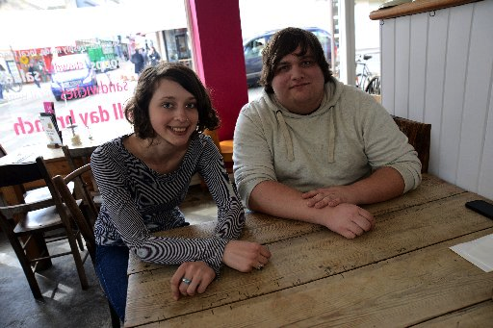 | What do you hope to get out of having a gig buddy?  …............................................................................................  …............................................................................................  …............................................................................................
What music are you into? (this could be types of music, like ‘rock’ or bands / singers, like ‘Beyonce’)
…............................................................................................

…............................................................................................
Do you enjoy any physical activities?
For example football, dancing, walking, swimming etc
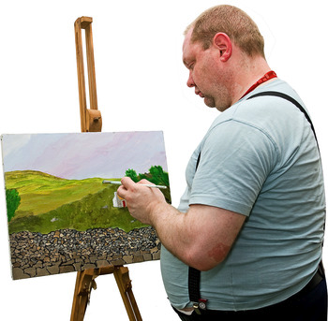 | What are your hobbies?  ….............................................................................................  ….............................................................................................
Please send this form to:
Stay Up Late
Room 4, Methodist Church
Stanford Avenue
Brighton
BN1 6FD

Thank you for contacting Gig Buddies.
One of the team will be in touch with you shortly to talk about what happens next.

