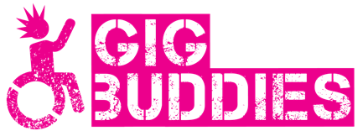

Covid safe Gig Buddying

We know that many of you (maybe all of us) are desperate to get back with seeing our friends again and a lot of you have been asking if you can see your buddies again.

We have been working to make this a safe thing for you to do and we have written this form as a way of enabling us to make this happen.

The sorts of activities that we are planning are:

- Up to 6 people meeting up in a park with lots of open space

- a walk so you can chat with your buddy

- meeting your buddy in a quiet café with tables outside

- a picnic in your garden

- one to one matching meetings

It is really important that we support you to do this safely and so we would like you to work through this form with your carer or support worker so they can also be sure that you have thought of any risks.

It’s really important to us that we enable people to see their friends again but we need to make sure we’ve done it well to keep you safe and everybody else.

We are also of course happy to talk about any questions or concerns that you may have.

Please read this carefully so you can meet up safely as part of the Gig Buddies project.

We need to know that you have read and understood this guide to meeting up safely.

Please can you read it with your carer or support worker?
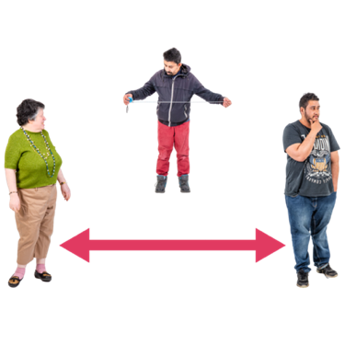 | You need to remember to stay 2 metres away from everyone else
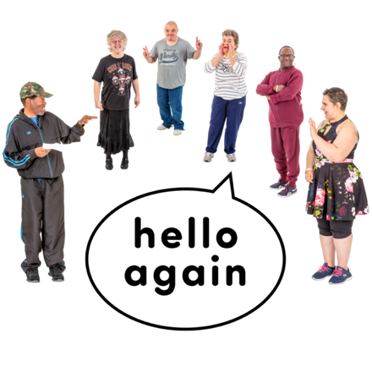 | It will be lovely to see everyone but we mustn’t hug, or shake hands.  Not even elbow bumps!  If we do meet up it will be outdoors and in small groups.
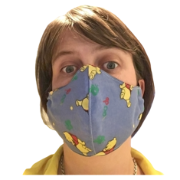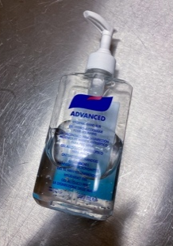 | You will need to make sure you know about things like:  Wearing a mask  Washing your hands
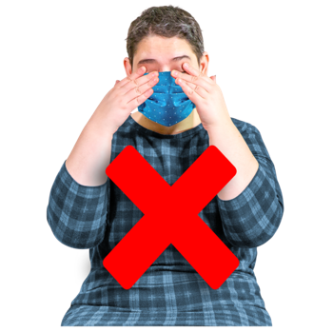 | Keep your hands away from your mask
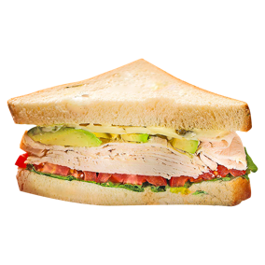 | If we’re meeting up for food just bring your own picnic.  You won’t need to share anything with anyone.
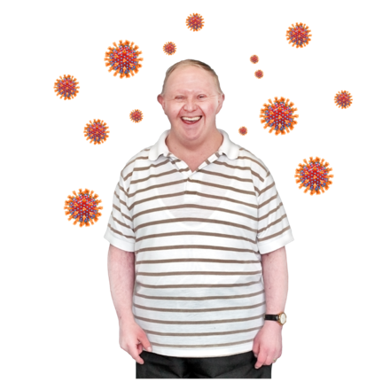 | Just because you feel well yourself doesn’t mean you couldn’t make someone else ill.  This form is to make sure we can all stay safe and well and meet up.
Questions
We now need you to answer these questions.

We hope you don’t find them too personal.

They will help us to know if we think it is a good idea for you to meet up with us.

- Have either of you been shielding? (Or living with anyone who has been shielding?)

- Do either of you have any ongoing health issues?
(Please tell us about any health issues that you may have)
- Do either of you live on your own or with other people?
- Have you read the information above?
Yes/No

- Are you happy that you can do all the things above so that you and everyone else stays well?
Yes/No

If you are not sure if you are particularly vulnerable to Covid-19 then please check the NHS website.
Here’s a link:
https://www.nhs.uk/conditions/coronavirus-covid-19/people-at-higher-risk/whos-at-higher-risk-from-coronavirus/#:~:text=People%20at%20moderate%20risk%20(,(such%20as%20hepatitis)

Or just Google ‘list of clinically vulnerable coronavirus’

When you have completed this form please keep a copy for yourself.
Please return the signed form to us by email
info@stayuplate.org

Or by post to
Stay Up Late, 2nd Floor Offices, Emmaus Brighton and Hove, Manor Road,
Portslade, BN41 2PA

Thank you and we hope to see you soon

