Equalities monitoring

We want to make sure that everyone is treated fairly and equally and that no one gets left out.

So we need to ask you some questions.

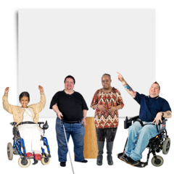 | We collect this information to understand who is accessing our project and sometimes we have use this information for reports.
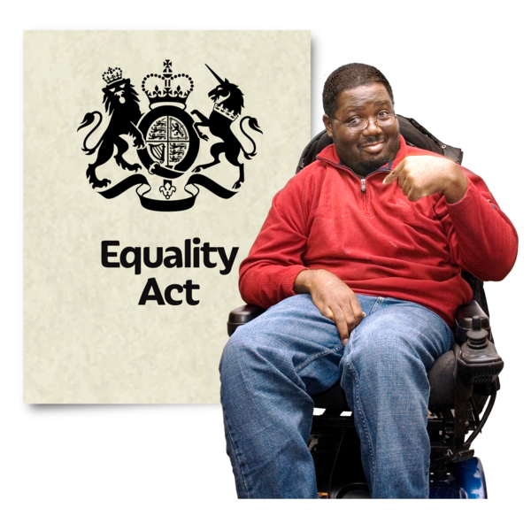 | We collect information under the Equality Act 2010. The act makes it unlawful to discriminate against anyone because of a characteristic.  The characteristics could be age, disability, race, religion and many others.
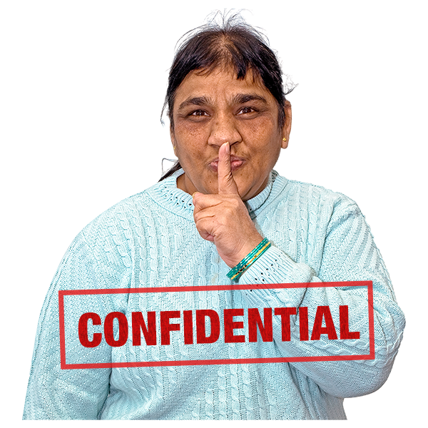 | We won't share the information you give us with anyone else.  We will only use it to help us make decisions and make our services better.
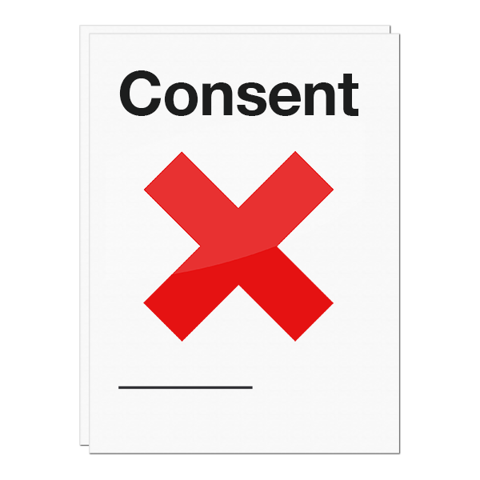 | If you would rather not answer any of these questions, you don't have to. If this is the case please send us back the unfilled form with your postcode (Q8)
Please fill out this form

Q1 Are you…. (please select one box)
- Male
- Female
- prefer not to say

Q2 Do you identify as transexual? (please select one box)
- Yes
- No
- Prefer not to say

Q3 Do you consider yourself to be disabled? (please select one box)
- Yes
- No
- Prefer not to say

Q4 Are you a carer? (please select one box)
- Yes
- No
- Prefer not to say

Q5 What is your sexual orientation? (please select one box)
- Bisexual
- Heterosexual/Straight
- Gay woman/Lesbian
- Gay Man
- Other
- Prefer not to say

Q6 Which of these ethnic groups do you feel you below to? (2001 Census)
Asian/Asian British
- Indian
- Pakinstani
- Bangladeshi
- Chinese
- Any other Asian background ___________________________

Black/African/Caribbean/Black British
- African
- Caribbean
- Any other Black/African/Caribbean background ______________________
Mixed/Multiple ethnic group
- Mixed White and Black Caribbean
- Mixed White and Black African
- Mixed White and Asian
- Any other mixed/multiple ethnic background ________________________

White
- English/Welsh/Scottish/Northern Irish/British
- Irish
- Gypsy or Irish Traveller
- Any other White background ______________________

Other ethnic groups
- Arab
- Any other ethnic group ___________________

Q7 What is your religion?
- No religion
- Christian
- Buddhist
- Hindu
- Jewish
- Muslim
- Sikh
- Any other religion _______________________

Q8 What is your postcode?

……………………………………………………….

Thank you for providing this information.
