Application form to have a Gig Buddy
Date: __________________________
Your name:

….......................................................................................

Your date of birth:
…...........................................................................................
Layout in table cell | Your address:  …..........................................................................................  ….........................................................................................  …...........................................................................................
Your telephone numbers:

Home: …....................................................................................

Mobile: …....................................................................................

Your email address:

…….........................................................................................
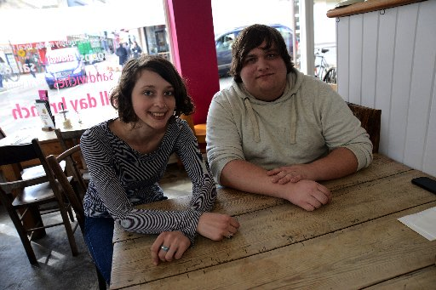 | What do you hope to get out of having a gig buddy?  …............................................................................................  …............................................................................................  …............................................................................................
Would you prefer your volunteer to be somebody who is:
☐ A woman
☐ A man
☐ Someone who doesn’t see themselves as either a man or woman
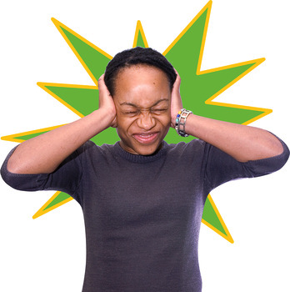  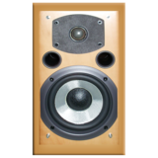 | How do you feel about crowds and loud music?  (you can stick to quieter gigs if you'd like)  …............................................................................................  ….............................................................................................
Do you use a computer for these things? (please tick):
☐ Facebook
☐ Twitter
☐ Email
☐ The internet in other ways
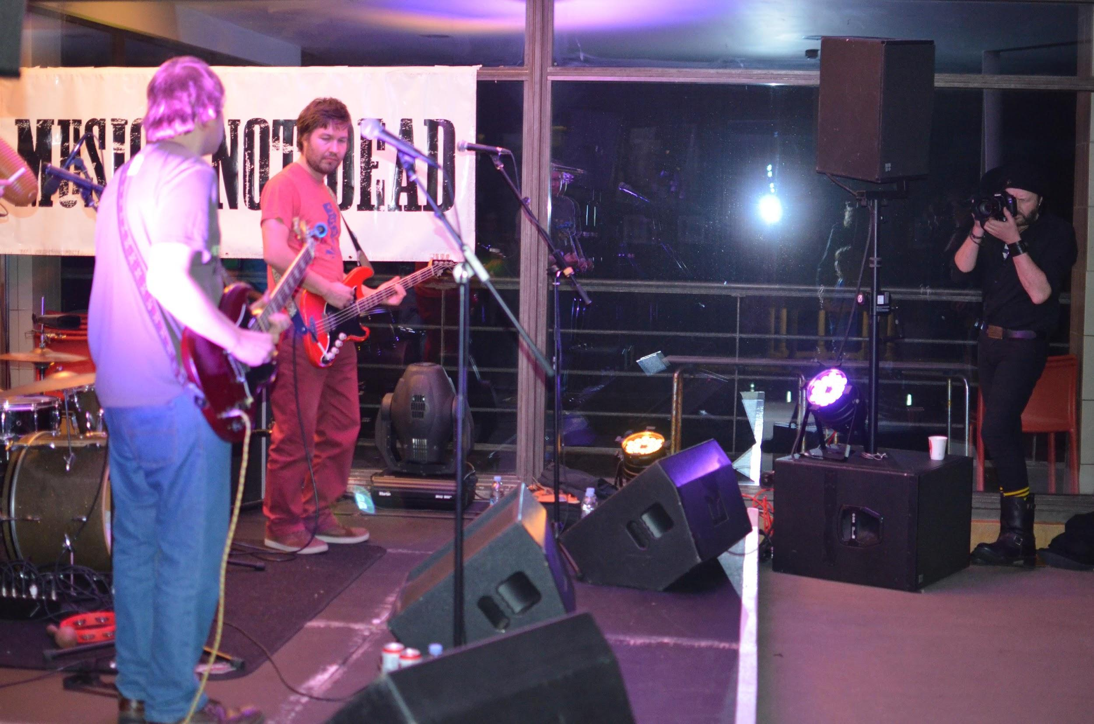 | When was the last time you went to a concert? (please tick):  ☐ Less than one month ago  ☐ A few months ago  ☐ More than 6 months ago  ☐ Never been to a concert
When was the last time you saw a live band in a pub/club? (please tick):
☐ Less than one month ago
☐ A few months ago
☐ More than 6 months ago
☐ Never seen a live band in a pub or club
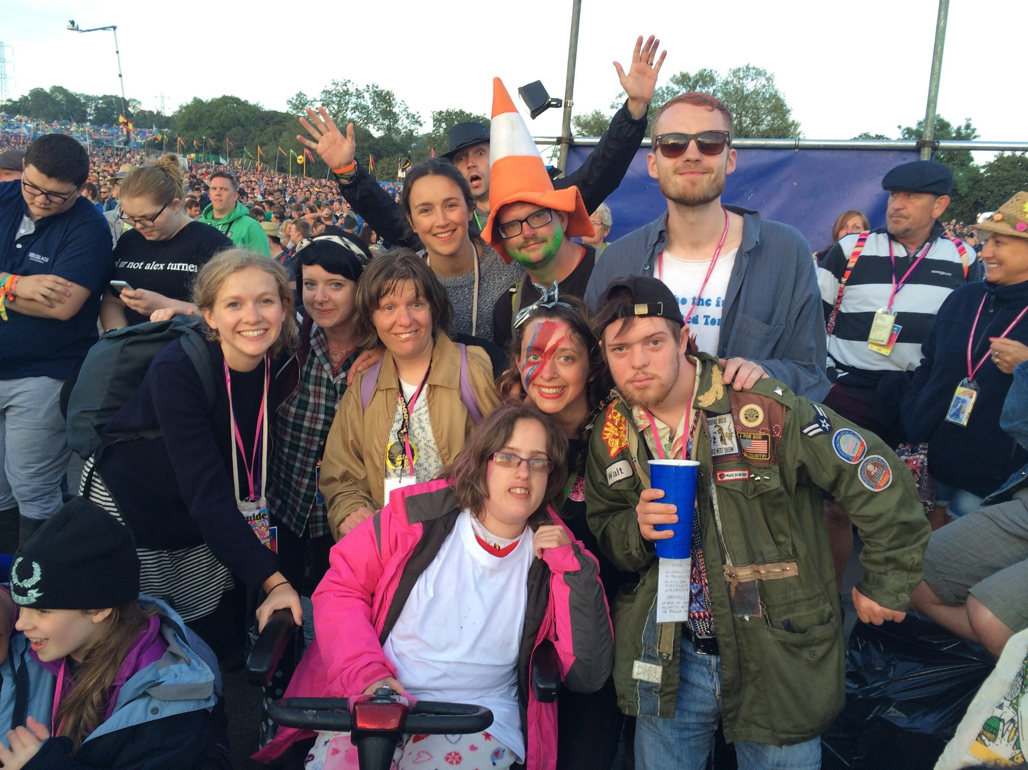 | Have you ever been to a music festival? (please tick):  ☐ Yes  ☐ No  ☐ I don’t know  If you have been to a music festival, which one was it?  ………………………………………………………………
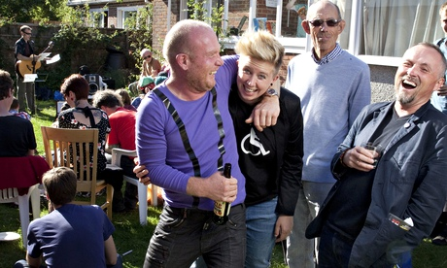 | How often do you go out with friends? (please tick):  ☐ Once a week or more  ☐ About once a month  ☐ Occasionally  ☐ Never
How often do you go out in the evening past 9pm? (please tick):
☐ Once a week or more
☐ About once a month
☐ Occasionally
☐ Never
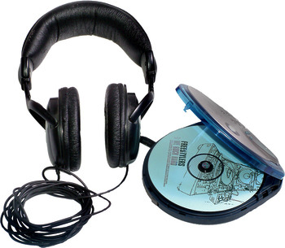 | What music are you into? (this could be types of music, like ‘rock’ or bands / singers, like ‘Beyonce’)  …............................................................................................  …............................................................................................
Would you like to try out new gigs and music you haven’t heard of?
☐ Yes
☐ No

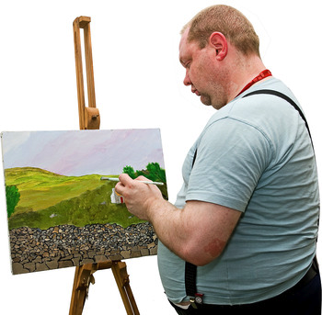 | What are your hobbies?  ….............................................................................................  ….............................................................................................
Is there anything else that your buddy will need to know about the support that you need?

…............................................................................................

….............................................................................................

Thank you for contacting Gig Buddies.
One of the team will be in touch with you shortly to talk about what happens next.

